*Laboratory Report*

**INTERNET TECHNOLOGIES LAB.**

**CAP5004L**

**School of Engineering**

**Department of Computer Science and Engineering**

|  |  |
| --- | --- |
| **Submitted By** | |
| **Student Name** | Amit |
| **Roll Number** | 180020307001 |
| **Section/Group** |  |
| **Department** | Computer Science and Engineering |
| **Session/Semester** | 2020-21/ Odd Semester |
| **Submitted To** | |
| **Faculty Name** | Ms. Manka Sharma |



**GD Goenka University**

Sohna road, Gurugram, Haryana

**Table of Content**

|  |  |  |  |
| --- | --- | --- | --- |
| Sl No | Date | Aim of the Experiment | Signature/date |
|  |  |  |  |
|  |  |  |  |
|  |  |  |  |
|  |  |  |  |
|  |  |  |  |
|  |  |  |  |
|  |  |  |  |
|  |  |  |  |
|  |  |  |  |
|  |  |  |  |

|  |  |  |
| --- | --- | --- |
| **Experiment No-2** | **Using the tags of HTML and the style properties of CSS, design the following forms (any Two)** | **Date:** |

**Aim of the Experiment:**

FORM 1

**Source Code - index.html**

<!DOCTYPE html>

<html lang="en">

<head>

<meta charset="UTF-8" />

<meta name="viewport" content="width=device-width, initial-scale=1.0" />

<link rel="stylesheet" href="style.css" />

<title>Form 2</title>

</head>

<body>

<div class="container">

<div class="card">

<div class="text-center">

<h1>&middot; keep in touch &middot;</h1>

<img

src="https://www.freepngimg.com/thumb/telephone/75364-antique-black-telephone-icon-free-download-png-hd.png"

alt=""

class="icon"

/>

</div>

<form action="" class="form">

<div class="text-center">

<input

type="text"

name=""

id=""

class="type type1"

placeholder="MY NAME IS"

/>

<input

type="text"

name=""

id=""

class="type type1"

placeholder="MY E-MAIL IS"

/>

</div>

<div class="text-center">

<input

type="text"

name=""

id=""

class="type type2"

placeholder="MY NUMBER IS"

/>

</div>

<div class="text-center">

<select name="" id="" class="type type2">

<option value="">SUBJECT LINE</option>

</select>

</div>

<div class="text-center">

<textarea

name=""

id=""

cols="30"

rows="5"

class="type type2"

placeholder="I'D LIKE TO CHAT ABOUT"

></textarea>

</div>

<button>SEND MESSAGE</button>

</form>

</div>

</div>

</body>

</html>

**Source Code - style.css**

body {

background: #e0e0e0;

font-family: -apple-system, BlinkMacSystemFont, "Segoe UI", Roboto,

"Helvetica Neue", Arial, "Noto Sans", sans-serif, "Apple Color Emoji",

"Segoe UI Emoji", "Segoe UI Symbol", "Noto Color Emoji";

font-weight: 400;

color: #212529;

text-transform: uppercase;

}

.container {

padding-right: 15px;

padding-left: 15px;

margin-right: auto;

margin-left: auto;

margin-top: 5%;

}

.card {

min-width: 0;

border: 3px solid #212529 !important;

max-width: 600px;

margin-right: auto;

margin-left: auto;

padding: 10px;

}

/* TEXT */

h1 {

margin: 0px !important;

letter-spacing: 5px;

padding-bottom: 10px;

}

.text-left {

text-align: left !important;

}

.text-right {

text-align: right !important;

}

.text-center {

text-align: center !important;

}

.border-bottom {

border-bottom: 1px solid #dee2e6 !important;

}

/* others */

.icon {

padding-top: 30px;

border-top: 2px solid #212529;

height: 50px;

}

.form {

margin-top: 50px;

}

.type {

margin-bottom: 1.5rem;

font-size: 1rem;

padding-bottom: 6px;

}

.type1 {

width: 48%;

height: 25px;

background: transparent;

border: none;

border-bottom: 2px solid #212529;

}

.type2 {

width: 98%;

height: 25px;

background: transparent;

border: none;

border-bottom: 2px solid #212529;

}

textarea {

font-family: -apple-system, BlinkMacSystemFont, "Segoe UI", Roboto,

"Helvetica Neue", Arial, "Noto Sans", sans-serif, "Apple Color Emoji",

"Segoe UI Emoji", "Segoe UI Symbol", "Noto Color Emoji";

height: auto !important;

}

button {

margin-left: 5px;

padding: 1rem 2rem 0.8rem 2rem;

background: transparent;

border: 2px solid #212529;

margin-bottom: 50px;

font-weight: 900;

}

**Output**

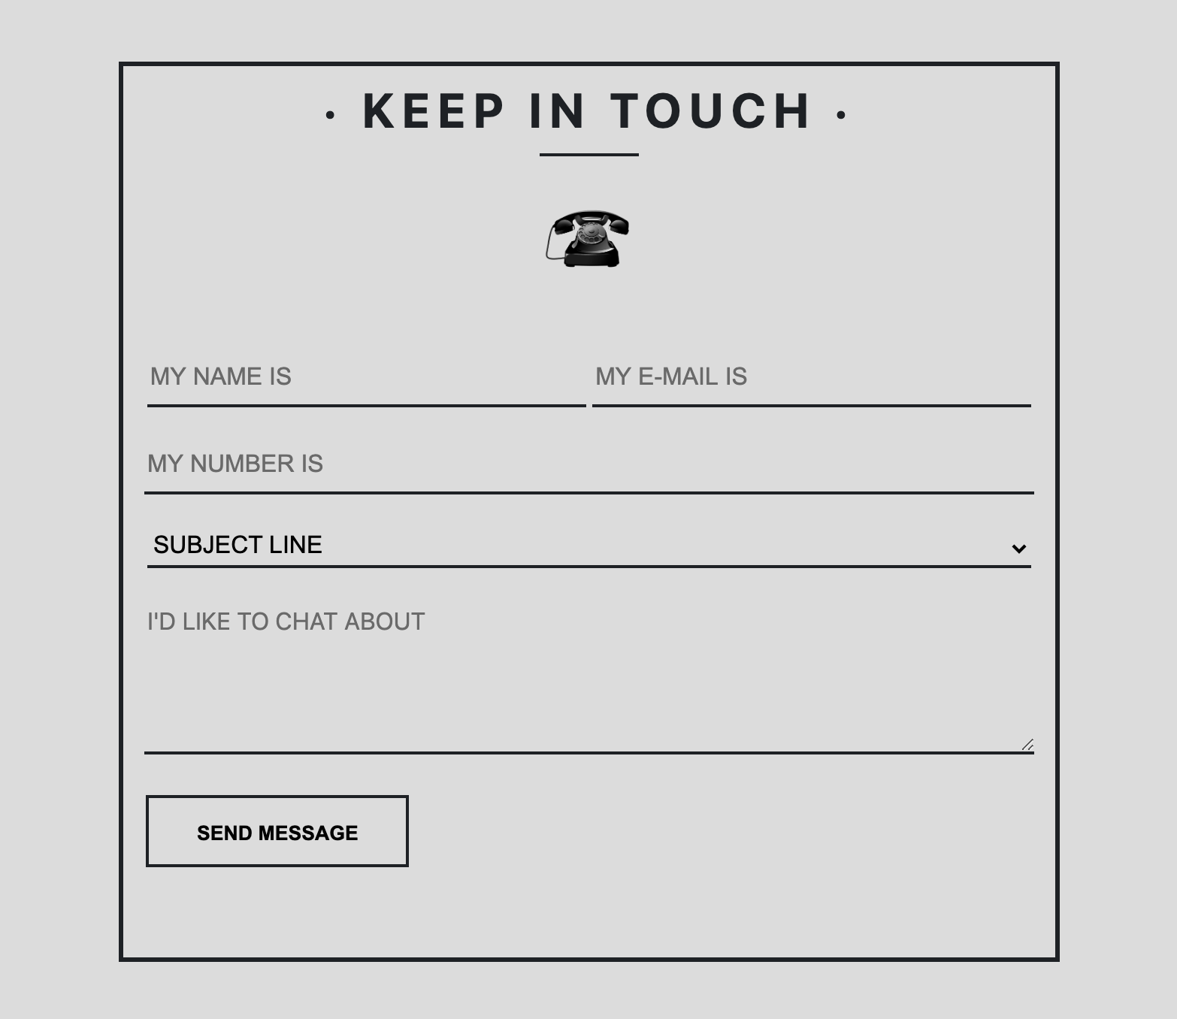

|  |  |  |
| --- | --- | --- |
| **Experiment No-1.1** | **Form 3** | **Date:** |

**Aim of the Experiment:**

Form 3

**Source Code - index.html**

<!DOCTYPE html>

<html lang="en">

<head>

<meta charset="UTF-8" />

<meta name="viewport" content="width=device-width, initial-scale=1.0" />

<title>Form 3</title>

<link rel="stylesheet" href="style.css" />

</head>

<body>

<div class="container">

<form>

<p><b>Step 1: Your details</b></p>

<div class="form">

<label>Name</label>

<input type="text" placeholder="First and last name" size="25" />

</div>

<div class="form">

<label>Email</label>

<input type="text" placeholder="example@domain.com" size="25" />

</div>

<div class="form">

<label>Phone</label>

<input type="text" placeholder="Eg. +4475000000" size="25" />

</div>

<p><b>Step 2: Delivery Address</b></p>

<div class="form formfield">

<label>Address</label><div align = "right">

<textarea rows="5" cols="21" role="textbox"></textarea></div>

</div>

<div class="form">

<label>Post Code</label>

<input type="text" size="25" />

</div>

<div class="form">

<label>Country</label>

<input type="text" size="25" />

</div>

<p><b>Step 3: Card Address</b></p>

<div class="form">

<label>Card Type</label>

<br /> <br>

<label class="radio-inline">

<input type="radio" name="credit" /><img

src="img/visa.png"

class="border-img"

/>

<span>Visa</span>

</label>

<label class="radio-inline">

<input type="radio" name="credit" /><img

src="img/amex.png"

class="border-img"

/>

<span>AmEx</span>

</label>

<label class="radio-inline">

<input type="radio" name="credit" /><img

src="img/mastercard.png"

class="border-img"

/>

<span>Mastercard</span>

</label>

</div>

<div class="form">

<label>Card Number</label>

<input type="text" size="25" />

</div>

<div class="form">

<label>Security Code</label>

<input type="text" size="25" />

</div>

<div class="form">

<label>Name on card</label>

<input type="text" size="25" />

</div>

<button>BUY IT!</button>

</form>

</div>

</body>

</html>

**Source Code - style.css**

body {

background: #e0e0e0;

font-family: -apple-system, BlinkMacSystemFont, "Segoe UI", Roboto,

"Helvetica Neue", Arial, "Noto Sans", sans-serif, "Apple Color Emoji",

"Segoe UI Emoji", "Segoe UI Symbol", "Noto Color Emoji";

font-weight: 400;

color: #212529;

}

.container {

border: 1px solid #9cbc36;

background-color: #9cbc36;

margin: auto;

max-width: 500px;

padding: 20px;

min-height: 80vh;

margin-top: 2.5vh;

border-radius: 1%;

box-shadow: 0 4px 8px 0 rgba(0, 0, 0, 0.2), 0 6px 20px 0 rgba(0, 0, 0, 0.19);

}

.form {

border: 1px solid #fff;

padding: 10px;

border-radius: 6px;

background-color: #b9cf6a;

margin-top: 2px;

}

input[type="text"] {

border: transparent;

border-radius: 2px;

padding: 3px;

float: right;

margin-right: 10px;

}

input::placeholder {

font-style: italic;

}

textarea {

border: transparent;

border-radius: 2px;

padding: 3px;

margin-right: 10px;

}

.formfield * {

vertical-align: top;

}

button {

border: transparent;

border-radius: 50px;

padding: 6px;

padding-left: 30px;

padding-right: 30px;

padding-top: 10px;

padding-bottom: 10px;

margin: 0 auto;

display: block;

background-color: #384313;

color: #fff;

margin-top: 10px;

}

img {

vertical-align: middle;

width: 16px;

}

.border-img {

border: 1px solid grey;

background-color: white;

padding-left: 4px;

padding-right: 4px;

border-radius: 5px;

margin-bottom: 5px;

}

**Output**

